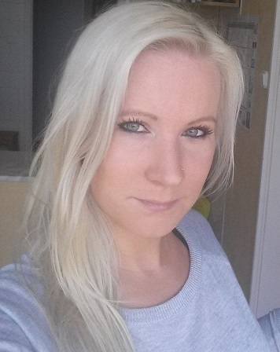
PETRA FARKAŠOVÁ

Phone: +421 905 254 784 vždy zadajte aj medzinárodnú telefónnu predvoľbu
E-mail: fpetrerrwre@gmail.com
Nationality: Slovak
DOB: 18/11/1984
address: Bratislavská u.34/Bratislava/811 07/Slovakia
positions applied for: Chambermaid, Housekeeper
available between: MAY 12 & SEPT 20
friend: sem zadajte meno vášho/ej kamaráta/ky, s kým by ste chceli vycestovať. Ak nemáte nikoho s kým by ste chceli ísť- vymažte tento riadok.

PERSONAL GOALS

I would like to gain my experience in international environment and develop my skills in the field of service. ( krátky motivačný list. 3 až 5 viet- aké máte ciele)

EDUCATION

2011 - 2012 Waiter & Cook (vzdelanie)
Táncsics Mihály Vocational School, Catering Faculty, Budapest (meno školy + mesto)
Main subjects: Meal preparation, Service

2011 - Waiter
del REY International Hospitality School, Budapest

2007 - 2011 Madách Imre High School, Gödöllő

EXPERIENCE

Piere-Anne Beach Hotel ****, Playa Blanca, Lanzarote, Spain – Chambermaid
www.piere-anne.com

Number of rooms: 290
Number of room/day: 12
Check-out cleaning: Yes
Daily cleaning: Yes
Nationality of customers: English, Spanish, German, French

Main responsibilities: (podrobný popis vašej pracovnej pozície)
-Complete cleaning tasks on assigned rooms, hotel areas and floors within the prescribed timeframes.
-Carry towels, linens, toiletry and cleaning supplies, using the assigned hotel wheeled carts.
-Perform the cleaning in accordance with hotel standards, safety and cleanliness standards.
-Clean waste bins, empty and clean/replace ashtrays, and dispose of all trash and waste items from rooms.
-Replenish kitchen and refrigerator supplies.
-Replenish drinking glasses, linens, writing supplies, and bathroom items.
-Ensure that service carts are well-stocked for the assigned floors and hotel areas.
-Sweep, mop and polish floors, using approved hotel cleaning tools.
-Clean rugs and carpets, upholsteries, curtains and draperies, using specified vacuum cleaners and shampooers.
-Dust window blinds and rearrange draperies to their original placements.

LANGUAGES

English conversational (intermediate language course) (úroveň a do zátvorky jazykový certifikát, ak máte)
Slovak native

SOCIAL SKILLS

I always polite and patient with the guests, I can work as a team member very well, but I can work on my own effectively. I learn quick. (čím podrobnejšie je, tým je lepšie- krátky popis, pracovné kompetencie)

